[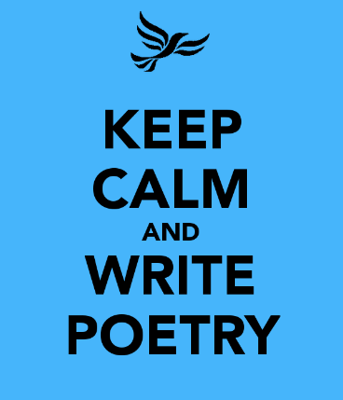](http://www.google.co.uk/url?sa=i&rct=j&q=&esrc=s&frm=1&source=images&cd=&cad=rja&uact=8&ved=0ahUKEwiy05CZu8rLAhUFKQ8KHbqPBeQQjRwIBw&url=http://www.redlinebookfestival.ie/competitions&bvm=bv.117218890,d.ZWU&psig=AFQjCNFonAvK8txwj6V5mkZaDcxsKGEzNg&ust=1458398301291080)Acrostic Poetry

An **acrostic poem** is a type of **poetry** where the first, last or other letters in a line spell out a particular word or phrase. The most common and simple form of an **acrostic poem** is where the first letters of each line spell out the word or phrase

|  |  |
| --- | --- |
| **B** is for Beautiful, you light up the room **E** is for Exceptional, simply outstanding **R** is for Reliable, a buddy you can count on **N** is for Nurturing, you bring out the good in people **A** is for Abilities, of which you have many **R** is for Remarkable, so exceptional **D** is for Dreamy, free from limits | **R** is for reception where you first go  **O** is for others who you don’t know  **C** is for cell , your new home  **H** is for happy when you’re alone  **E** is for evening association for all  **S** is for sentence inside this wall  **T** is for time, you have to do  **E** is for ever, it feels like for you  **R** is for restart when you time is done |
| **Bernard** | **Rochester** |
| **J** is for Jolly, brimming with joy **A** is for Amiable, so friendly and warm **C** is for Chipper, your cheer is infectious **K** is for Kind, generous to people **S** is for Sensible, you always do the right thing **O** is for Optimistic, always looking up **N** is for Nutty, full of wackiness | **J** is for Just, fair to everyone **O** is for Obliging, accommodating towards people **H** is for Hyperactive, nothing ties you down **N** is for Noble, an honourable heart  **B** is for Brilliant, you have a beautiful mind **R** is for Receptive, an open mind **O** is for Oomph, you have a magnetic draw **W** is for Well-mannered, refined in behaviour **N** is for Nice, a sweet soul |
| **Jackson** | **John Brown** |

|  |  |  |
| --- | --- | --- |
| Fancy writing | **A** | poem |
| Pi | **C** | k a topic of your choice |
| You can w | **R** | ite about anything |
| Let y | **O** | ur imagination run wild |
| Cho | **S** | e the right words |
| Writing your | **T** | houghts on paper |
| Nothing | **I** | s impossible |
| Be | **C** | reative |